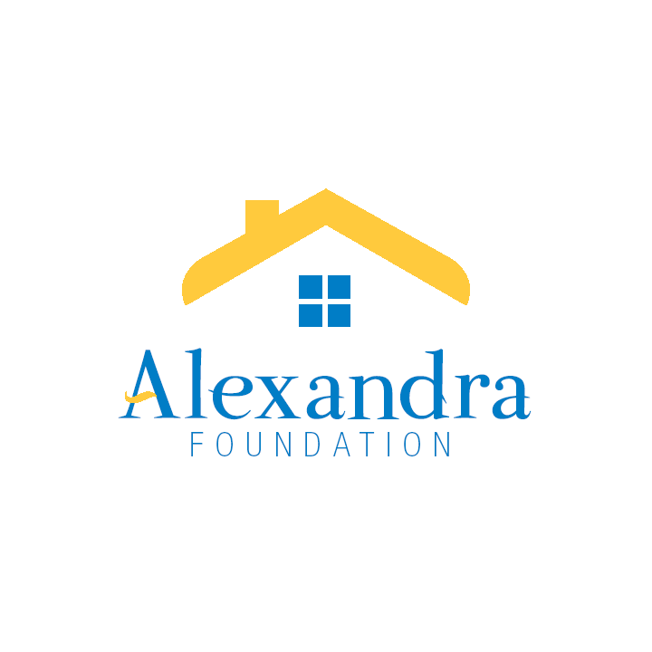

**THE ALEXANDRA FOUNDATION FOR NEIGHBOURHOOD HOUSES**

203-3102 Main Street, Vancouver BC V5T 3G7

Tel: 604-875-9111 Fax: 604-875-1256 E-mail: grants@alexandrafoundation.org

[www.alexandrafoundation.org](http://www.alexandrafoundation.org)

**GRANT APPLICATION FORM**

**Stream 2: Projects for Existing Neighbourhood Houses**

**Maximum grant available is $50,000**

This grant stream is focused on two areas of support:

1. Flexible funds that contribute to sustainability of Neighbourhood Houses, including: enhancing infrastructure, core operations, governance, and community capacity building.
2. Sector building activities that build awareness of Neighbourhood Houses and their impact.

e.g., joint publicity campaign, employee and volunteer development, NH sector organizing for policy development, NH sector organizing to address a broad community issue.

The Foundation may consider multi-year grants where the need and impact is clearly demonstrated.

**Please review the** [**Grant Project History**](https://alexandrafoundation.org/organization-grants/grant-project-history/) **page on the Foundation’s website for examples of projects the Foundation has supported.**

|  |  |
| --- | --- |
| **Annual Submission Timelines** | **Annual Approval Timelines** |
| Apply before **April 30** | Grants approved by June 30 |

## SECTION 1: APPLICATION INFORMATION

Organization’s Legal Name:

Address:

Postal Code:

Phone number:

Website:

What year was your organization registered?

Canada Revenue Agency charitable registration BN:

Contact Name:

Title:

E-mail address:

Phone number:

## SECTION 2: ORGANIZATION INFORMATION

1. Project name
2. History/background of your organization?
3. Your organization’s purpose or mission
4. Amount of funding requested from the Alexandra Foundation

## SECTION 3: PROJECT INFORMATION

1. Project statement: briefly describe the issue you hope to address and the change you will create as a result of this project.
2. Describe the proposed initiative or project, including:
   * 1. Why this project is needed - provide supporting data and/or direct experience of the issue being addressed;
     2. How the initiative meets your organization’s mission or objectives;
     3. Where the project is located;
     4. Specific goals and objectives;
     5. Specific activities to achieve your objectives;
     6. Project timelines and deliverables.
3. Tell us about the partners you are working with and their contributions to the project including any matching funds or in-kind contributions:
   * 1. Describe engagement /contributions from different levels of government.
     2. Describe engagement/contributions from other funders.
     3. Describe engagement/contributions from community partners.
4. How will you know your project was successful?
5. Describe the expected results and benefit(s) for the NH, neighbourhood/community, or sector;
6. Describe how you will measure the results.
7. Why is funding from Alexandra Foundation necessary? What will happen if this application isn’t successful or is only partially successful?
8. Proposed budget, including revenue from all sources and budgeted expenses. Please use budget template provided.
9. Provide a short paragraph describing the issue you will address and how change will be accomplished through this project. This paragraph will be shared with the public.
10. Indicate how you will acknowledge the Alexandra Foundation grant.

## SECTION 4: CHECKLIST

The following information must be attached to your application. If you need help completing this form, please contact the Executive Assistant at 604-875-9111 ext. 106 or via email Attention Executive Assistant at [grants@alexandrafoundation.org](mailto:grants@alexandrafoundation.org).

For all applicants, include:

* This application form
* Your project budget
* Most recent Annual General Meeting minutes
* Authorizing signatures

## SECTION 5: CONDITIONS

1. The funds will be only used for the project and purpose as approved by the Alexandra Foundation.
2. A Final Report, Evaluation and a Financial Statement for the full initiative are required within 90 days upon completion of the project.
3. If there is a lengthy interruption on a project for which Alexandra Foundation funds have been granted, your organization must notify the Foundation immediately.
4. If all the funds are not used, any unused portion of the grant amount received should be reported to the Alexandra Foundation.
5. Alexandra Foundation’s support must be acknowledged in all communication and promotional materials pertaining to this project.

## SECTION 6: SIGNATURES

This application must be signed by an authorized signing officer of your Board of Directors.

Please indicate your acceptance of the above noted terms and conditions by executing and returning this form to the Alexandra Foundation, where upon the agreement herein set forth shall become effective.

Board Chair Signature Print Name Date

Executive Director Signature Print Name Date