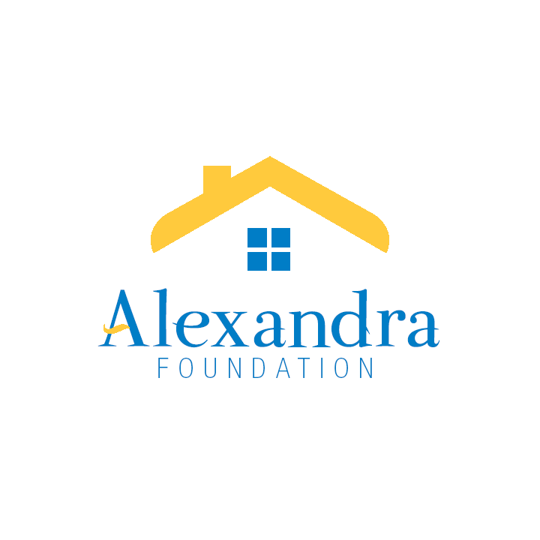

**THE ALEXANDRA FOUNDATION FOR NEIGHBOURHOOD HOUSES**

203-3102 Main Street, Vancouver BC V5T 3G7

Tel: 604-875-9111 Fax: 604-875-1256 E-mail: central@anhbc.org

[www.alexandrafoundation.org](http://www.alexandrafoundation.org)

**GRANT APPLICATION FORM**

**Stream 1: New Neighbourhood House Initiatives**

**Maximum grant available is $50,000**

This grant stream focuses on the early stages of development for new neighbourhood houses: from assessing feasibility through the first five years of neighbourhood house launch and growth.

The Foundation may support projects over multiple years to help maintain momentum of multi-phased development.

|  |  |
| --- | --- |
| **Annual Submission Timeline** | **Annual Approval Timeline** |
| Apply before **April 30** | Grants approved by June 30 |

## SECTION 1: APPLICATION INFORMATION

Organization’s Legal Name:

Address:

Postal Code:

Phone number:

Website:

What year was your organization registered?

Canada Revenue Agency charitable registration BN:

Contact Name:

Title:

E-mail address:

Phone number:

## SECTION 2: ORGANIZATION INFORMATION

1. Project name
2. History/background of your organization?
3. Your organization’s purpose or mission
4. Amount of funding requested from the Alexandra Foundation

## SECTION 3: PROJECT INFORMATION

1. Project statement: briefly describe the issue you hope to address and the change you will create as a result of this initiative.
2. Describe the proposed initiative or project, including:
3. How the initiative meets your organization’s mission or objectives;
4. Where the project is located;
5. Specific goals and objectives;
6. Project activities, timelines and deliverables;
7. Anticipated results and benefit(s) it will have in the neighbourhood/community; and
8. How will you know you’re successful? What measures will you use?
9. What evidence has been gathered to demonstrate the need for a neighbourhood house?
   1. Describe stakeholder engagement. What has been learned?
   2. Provide demographics/data and relevant information about the neighbourhood and population you hope to serve through this project.
10. Demonstrate that you operate by the values and principles of the neighbourhood house movement by showing how your organization:
11. Is governed by an active community advisory group;
12. Is responsive to local priorities and needs;
13. Encourages and champions diversity in all facets of the organization; and
14. Provides or intends to provide a welcoming “open-door” environment for neighbours to gather.
15. Tell us about the partners you are working with and their contributions to the project.
16. Identify all community partners and their contributions to the project.
17. What additional community partnerships are needed?
18. Describe engagement/contributions from different levels of government including your local municipality, the Province of BC and Federal government.
19. Describe support/contributions from other funders.
20. What practical supports and resources are you utilizing to help you develop and deliver this project?
21. Describe how your organization is building capacity to develop a new neighbourhood house. For example, describe any practical supports, mentorship and resources utilized such as the [ANHBC Toolkit for Start-Ups](https://alexandrafoundation.org/alexandra/wp-content/uploads/sites/6/2017/09/ANHBC-Toolkit-for-Starting-and-Sustaining-a-Neighbourhood-House-201521.pdf).
22. What role (other than funding) could the Alexandra Foundation play in supporting the development of this neighbourhood house?
23. Proposed budget, including revenue from all sources and budgeted expenses. Please use budget template provided.
24. Provide a short paragraph describing the issue you will address and how change will be accomplished through this project. This paragraph will be shared with the public.
25. Indicate how you will acknowledge the Alexandra Foundation grant.

## SECTION 4: CHECKLIST

The following information must be attached to your application. If you need help completing this form, please contact the Executive Assistant at 604-875-9111 ext. 106 or via email Attention Executive Assistant at [grants@alexandrafoundation.org](mailto:grants@alexandrafoundation.org).

For all applicants, include:

* This application form
* Your project budget
* Most recent Annual General Meeting minutes
* Authorizing signatures

## SECTION 5: CONDITIONS

1. The funds will be only used for the project and purpose as approved by the Alexandra Foundation
2. A Final Report, Evaluation and a Financial Statement for the full initiative are required within 90 days upon completion of the project.
3. If there is a lengthy interruption on a project for which Alexandra Foundation funds have been granted, your organization must notify the Foundation immediately.
4. If all the funds are not used, any unused portion of the grant amount received should be reported to the Alexandra Foundation.
5. Alexandra Foundation’s support must be acknowledged in all communication and promotional materials pertaining to this project.

## SECTION 6: SIGNATURES

This application must be signed by an authorized signing officer of your Board of Directors.

Please indicate your acceptance of the above noted terms and conditions by executing and returning this form to the Alexandra Foundation, where upon the agreement herein set forth shall become effective.

Board Chair Signature Print Name Date

Executive Director Signature Print Name Date