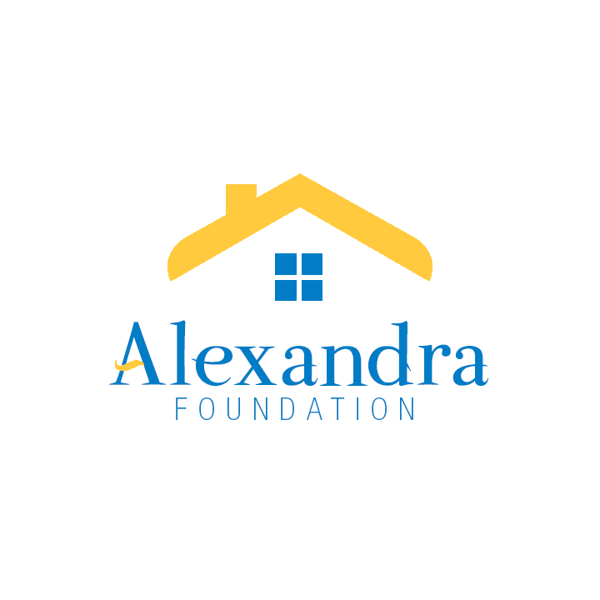

THE ALEXANDRA FOUNDATION FOR NEIGHBOURHOOD HOUSES
203-3102 Main Street, Vancouver BC V5T 3G7
Tel: 604-875-9111 I Fax: 604-875-1256 E-mail: central@anhbc.org
www.alexandrafoundation.org

GRANT FINAL REPORT
Narrative

A final narrative report and budget report for funded projects are required within 90 days of completion of the project. The information is used to help evaluate the effectiveness of our grants and better understand how an organization used the funds received.

Date of Submission:

ORGANIZATION INFORMATION

Organization’s Legal Name:
Address:
Postal Code:
Phone number:

Contact Name:
Title:
E-mail address:
Phone number:

PROJECT INFORMATION

- Project Name:
- Project start date:
- Project end date:
- Brief description of project/activity you received for:

PROJECT OUTCOMES

- Based on the application submission, have you met all the objectives of your project’s goals? Yes No
- If no, please tell us about any unmet goals or objectives.
- How successful was the project in achieving the intended impacts? Please identify specific results and measures used to quantify them.
- What factors contributed to your success?
- Describe any unanticipated outcomes, benefits or challenges encountered with this project.
- Please share how the Alexandra Foundation’s support has benefited your project (this may be posted on the Alexandra Foundation website or other promotional materials).

Grant amount received from the Alexandra Foundation: $

BUDGET REPORT SUMMARY

Budgeted cost of project: $
Actual cost of project: $
At completion of the project, did you use all the funds granted from the Alexandra Foundation?

Attach a completed “AF Application and Reporting – Budget” form, provided.

Thank you!

